# Communications strategy template

Not for profit communications workshop

This template is to help guide you through the strategic communications workshop to enable you to develop a communication strategy for your organisation. We recommend using this as a digital document that you can fill in on the day and continue to update after our session.

Any text in *italics* are notes for you and can be deleted in the final version.

# Introduction

*Provide a summary of the project or organisation you are developing the communication strategy for. Think about:*

* *Why did you pick this topic?*
* *Who do you need to engage after the session?*
* *Do you have timeframes or a deadline you need to meet?*

# Purpose

*What is the issue and opportunity? Why is it important?*

The purpose of this communication strategy is to…

# Goals

*What are you setting out to achieve and how does it link to the organisational goals, business outcomes or strategic priorities?*

This communication strategy is setting out to achieve:

|  |  |
| --- | --- |
| 1 |  |
| 2 |  |
| 3 |  |

# Operating environment

*The operating environment impacts the delivery and influence of communications activities. Understanding this environment allows for decisions to be made based on a deeper understanding of how the audience may perceive the information and use channels.*

Analysis using the PESTLE model has been undertaken to understand the internal and external operating environment as at (DATE). By understanding these factors, it's possible to maximise our opportunities and minimise risks.

|  |  |
| --- | --- |
| **Political** |  |
| **Economic** |  |
| **Social** |  |
| **Technology** |  |
| **Legal** |  |
| **Environmental** |  |

# Objectives

*An objective is a precise, measurable statement that indicates the steps needed to achieve the goals.*

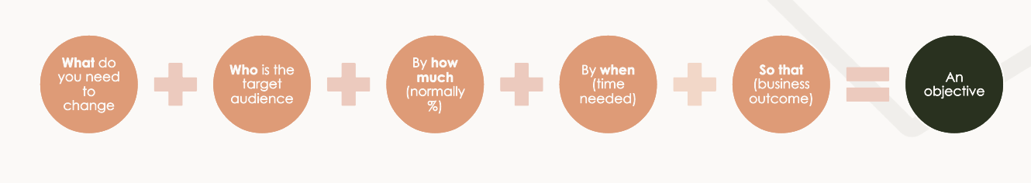

The objectives for this strategy are:

|  |  |
| --- | --- |
| 1 |  |
| 2 |  |
| 3 |  |

# Audiences

*For communication to be strategic, specific audiences need to be targeted for different messages, tactics and channels.  The people who need to receive the messages to achieve the objectives. Consider not only the main audience (primary) but also the secondary audience, those who influence the primary audience.*

This is what we know about our primary and secondary audiences:

**Primary audience**

|  |  |
| --- | --- |
| **Audience** | **Who are they? Needs and characteristics** |
|  |  |
|  |  |
|  |  |
|  |  |
|  |  |

**Secondary audience**

|  |  |
| --- | --- |
| **Audience** | **Who are they? Needs and characteristics** |
|  |  |
|  |  |
|  |  |
|  |  |
|  |  |

# Key messages

*The key information you need to get to your audience to meet the objectives. Not a list of everything you need to say just the topline information you consistently need to get across.*

# Channels

*Select the right channels to get the messages to the target audience to meet the objectives.*

* *Owned – Website, annual report, emails, blogs.*
* *Interpersonal – Meetings, face-to-face visits, site visits, email, phone calls.*
* *Paid –Advertising, online placement.*
* *Social – Tweets, blogs, Facebook posts, LinkedIn articles*
* *Uncontrolled, earned media – Media releases, interviews, podcasts.*
* *Events – Workshops, webinars, conferences*
* *Shared – Alliances, other organisations/industry groups to work with, third parties to send out messages.*

We will utilise the following channels in this strategy to reach our audiences:

|  |  |
| --- | --- |
| **Channel** | **Audience** |
|  |  |
|  |  |
|  |  |
|  |  |
|  |  |
|  |  |
|  |  |

# Implementation plan

*There are two options for your implementation plan. You can list the activities:*

|  |  |  |  |  |  |
| --- | --- | --- | --- | --- | --- |
| **Activity** | **Goal/Objective** | **Audience** | **Channel** | **Details** | **Timeline** |
| ***What will we do to achieve our goals*** | ***What are we trying to achieve*** | ***Audience group/s targeted for this activity*** | ***Best channel to engage audience to achieve objectives*** | ***What do we need to develop and what steps do we need to take*** | ***When do we need to do this by*** |
|  |  |  |  |  |  |

*Or you can develop a simple timeline of activities.*

|  |  |  |  |  |  |  |
| --- | --- | --- | --- | --- | --- | --- |
| Period | July | August | September | October | November | December |
| Activity/Deliverables  What do you need to deliver and when? |  |  |  |  |  |  |
| Audience – Who are you focused on? |  |  |  |  |  |  |

# Measurement & evaluation

*A strategy is only good if you know that it worked. Measurement and evaluation are just as important as the delivery.*

* *Outputs – how many things did you produce? Number of posts, media releases, meetings?*
* *Outcomes – what worked? Engagement, sentiment, behaviour change.*
* *Alignment – were the objectives met?*
* *Lessons learned – what would you do differently next time?*

The progress and success of this strategy will be measured through:

|  |  |  |
| --- | --- | --- |
| Objective | Measurement (do it now)  what data do you have to measure this objective? | Evaluation (do it later)  What was the outcome? |
| Objective 1: |  |  |
| Objective 2: |  |  |
| Objective 3: |  |  |